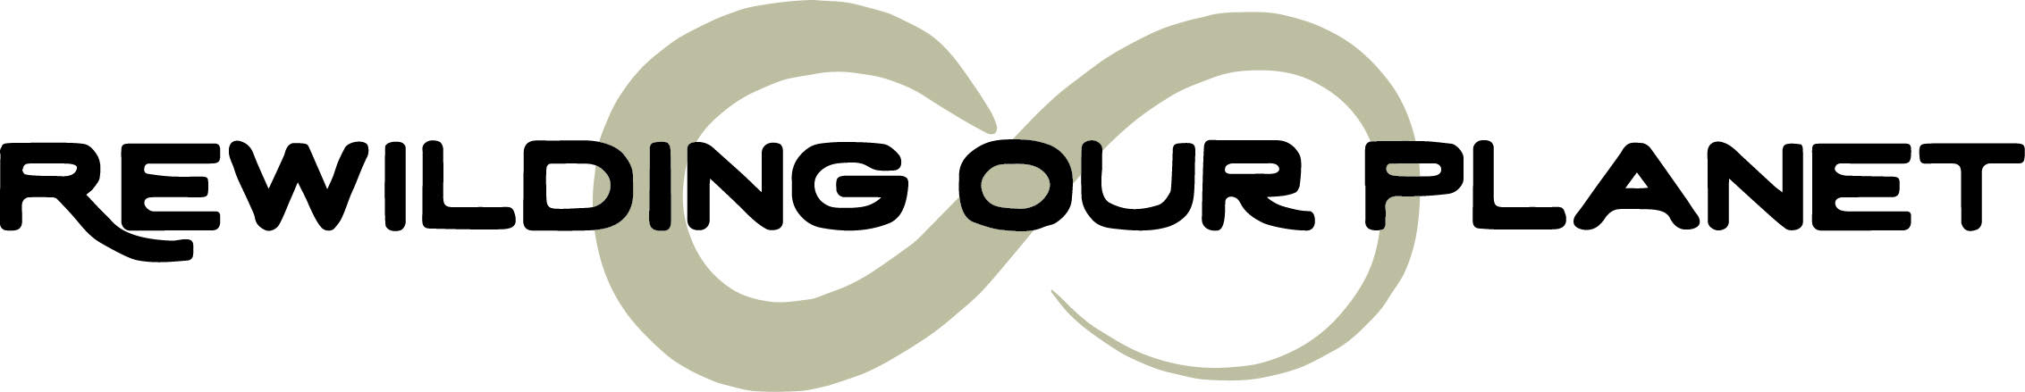
Co-Creation Opportunity
Name: | Preferred method of contact:
Date of Birth: | Current Role/ Organisation:
Tel (Whats App): | Address:
Email:
Skype/ Zoom:

Why would you like to be part of this project?
What skills would you like to bring to it?
What skills would you like to develop?
What does your heart call for?
How would you like the relationship to be in this co-creation?
How did you hear about this project?
Anything else you wish to tell us?
What dates would you like to come to the land?
Would you like individual Constellation Coaching? Cost is 30 Euro per session for individuals living on the land.

Please advise on any health issues either physical or mental?

I confirm that the information I have given above is correct.

Signed: Date:

Thank you for your time filling out this form, please return to:
Deborah on hello@deborahrichmond.co.uk

